Burj khalifa

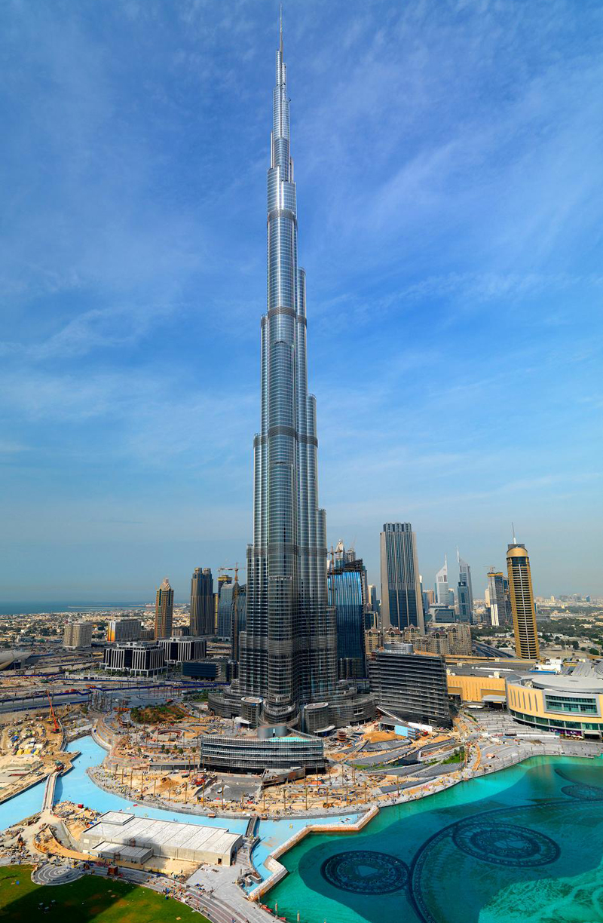
Submitted to:
Vidya Narayan
Group Members:
Manpreet Kaur Thind
Charandeep Kaur
Bhinderjit Singh
Ankit Yadav

Table of Contents

- Final Outcome of Team 03
- Tools And Documents Used 04
- Success Or Failure 05
- Things That Went Right and Wrong 06
- Learning Outcome 08
- Group Leader 10
- Team Effort 12
- Following up Plan 13

Final Outcome of Our team

Our team worked on the project named Burj Khalifa. Our team has found various amazing facts about Burj Khalifa project that is history behind the project, proposed ideas, difficulties that were faced while establishing the project and how was the project initialized and completed.
Burj Khalifa was designed to be the centerpiece of a large-scale, mixed-use development that would include 30,000 homes, 3 hectares (7.4 acres) of parkland, at least 19 residential towers, the Dubai Mall, 12-hectare (30-acre) man-made Burj Khalifa Lake.
The decision to build Burj Khalifa is reportedly based on the government's decision to diversify from an oil based economy to one that is service and tourism based. According to officials, it is necessary for projects like Burj Khalifa to be built in the city to garner more international recognition, and hence investment.This is only the conception of Burj Khalifa.

We researched alot on the history of height increases: There are unconfirmed reports of several planned height increases since its inception. Originally proposed as a virtual clone of the 560 m (1,837 ft.) Grollo Tower proposal for Melbourne, Australia'sDocklands waterfront development, the tower was redesigned by Skidmore, Owings and Merrill (SOM). Marshall Strabala, an SOM architect who worked on the project until 2006, in late 2008 said that Burj Khalifa was designed to be 808 m (2,651 ft.) tall.

In short, this project is very vast as it has a huge history beside its construction,height,etc.Thats why, we did brief research on all the phases of this project such as planning,designing and implementing etc.

Tools & Documents Used

We basically used the Microsoft office 2010 to complete this project in many ways.We used microsoft word to write the project notebook and other little information searched on this project.We also used microsoft powerpoint to prepare our presentation slides. We used Microsoft Project Management tool to plan, initiate, design and complete this project. Gantt chart was prepared using Microsoft Project Management that gave clear view on working hours of each individual, deadline of the deliverables and division of the task.We also used other tools to create our website of the project such as notepad++.
These tools really helped us alot to accomplish our project properly on time.

Success Or Failure
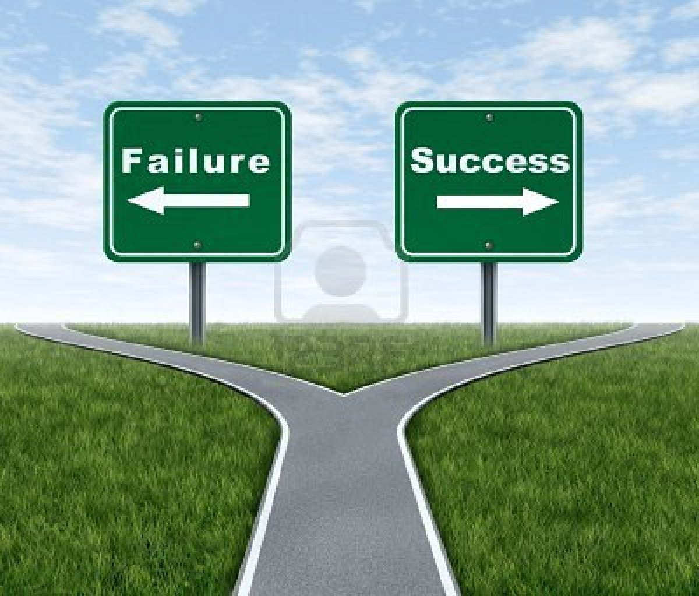

The Burj Khalifa project was a complete success. The hard work and dedication helps a lot to accomplish that project. From the point of quality: The project is successful.The net profit increased 10 times compared to 2009. In June 2010, Burj Khalifa was the recipient of the 2010 Best Tall Building Middle East & Africa award by the Council on Tall Buildings and Urban Habitat. On 28 September 2010 Burj Khalifa won the award for best project of year at the Middle East Architect Awards 2010.

Things Went Right in Project

Overall our team did best on researching the whole project Burj Khalifa and then designing and implementing the website to present that researched information clearly. As mentioned above the Microsoft Office 2010 was used to initiate and complete that project. We had divided our work in 4 equal parts. Our project leader did a great job in managing the whole project, dividing the tasks based on the ability, knowledge and without any partaility. All group members did their job very well.This was the success key for our project. We actually didn’t wait till the last moment to complete our work.

Things Went Wrong in Project

Although we were able to complete the whole project on time, however, time was a key factor in this project. As it was initialized and built almost 50 years ago, it was very tough researching on this project. Furthermore, the stages of the project, written documents were some things that we were not able to come up easily.

Learning Outcome from this Project

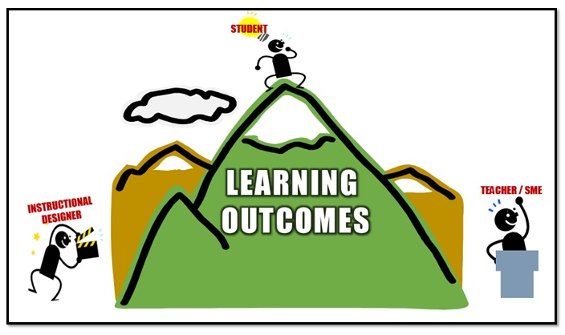

There are many things we have learned while working on this project
- Using Microsoft Project Management tool
- Planning and organizing
- Enhanced decision-making skills
- Gained knowledge from team members
- Time management
Finally, working in team provided us a practical real-life experience. We learned various stages of project management, risks and benefits of project while working on this project.

Group Leader

Ankit Yadav is the project manager of our group. He has an exceptional team leading qualities which we just witnessed in our last semester. Undoubtedly, all the group members of our team decided to have her as a project Manager. He leads the team from front. In the beginning she created the document to divide all the tasks among all the team members.

Team Effort
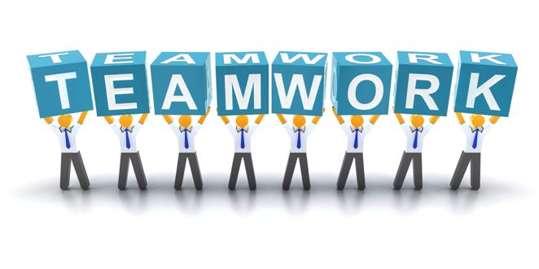
“Teamwork divides the task and multiples the success.”
I would say this project should have not been completed if all the members didn’t play their roles. It was a team effort through which we are able to complete this project.
All the members completed their tasks as planned and deliverables were completed on time that led this project to completion.

Following up Plan

The key to success of this project was to follow the plan that we made earlier. Planning is the building stone of every project. As discussed earlier, we created project report and divided the whole report into bunch of deliverables. The deadlines were set for those deliverables. Following up the deadlines, we completed our deliverables and in the end we summed up all our completed work.

